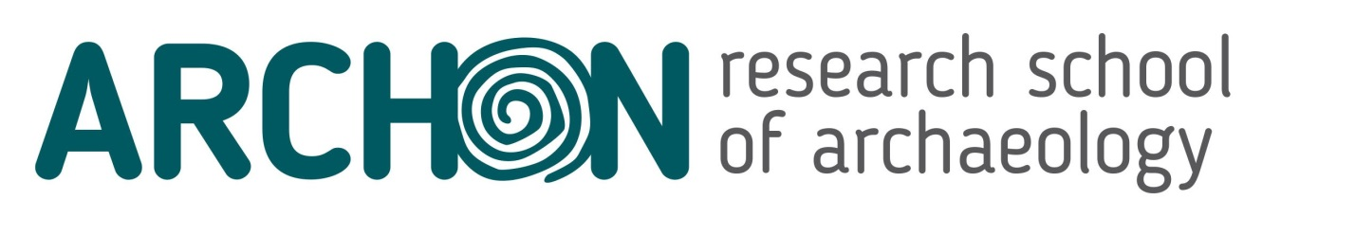
Standard form for event proposals
Please fill out the form as indicated.
Title | Please enter the title of the event (only one line)
Organisers + contact details | Please enter the names of the organisers, and their contact details. These should be from at least two separate institutes participating in ARCHON.
Date | Please enter the intended date(s) of the event
Venue | Please enter the intended venue for the event  University of Leiden / VU Amsterdam / University of Amsterdam / University of Groningen / RCE Amersfoort / other
Event type | Seminar / Workshop / Training school / other, or a combination of these. A detailed setup should be provided in the programme structure document.
Intended audience | RMA students and/or  PhD students and/or  Staff members
Open to ARCHON members only? | Yes / No  If No, please indicate what other groups will be targeted
Number of participants | Please enter an estimate of the number of ARCHON participants
Credits | Number of ECTS that can be obtained by participating in the event by RMA and PhD students. As a rule of thumb, 1 ECTS corresponds to 28 hours of study, so make sure that the assessment (below) is balanced to the duration of the event.
Assessment | Type of assessment used  Writing an essay / Writing a review / Doing an interview / Making a video / Doing a presentation / Practical assignment / Other (or combination)
Learning goals | State the learning goals for the RMA and PhD student participants (to be formulated as: after this event, students can / have learned to / understand …)
List of speakers / teachers | Please only enter the names of speakers / teachers who have confirmed their availability, and state their role in the event.
Abstract | Describe the contents of the event in max. 250 words. This abstract should be suitable for advertising on the Archon website.
Diversity and inclusivity | Please indicate how you will ensure diversity and inclusivity of the event. This can be by  - explicitly including diversity and inclusivity as a theme  - inviting speakers from diverse backgrounds  - inviting attendants from diverse backgrounds  - facilitate participation for those attendants
Budget | Specify the full budget for the event, and indicate the requested contribution from Archon. Archon event support is max. €1200

